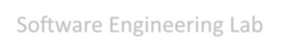
Software Engineering Lab

Group Number – 22

Group Members :-

Ishwari Mahajan- 202301040173
Omkar Londhe - 202301040027
Sneha Nannaware- 202301040267
Yashraj Jagtap- 202301040092
Om Thorat - 202301040155
Sumit Khetre – 202401040017

Company Details – Organization: Senim Solutions LLP

Name: Pravin Pawane (CEO - pravin.pawane@senim.in )
Location: Bhosari , Pune

Assignment :- Prepare a suitable cost estimation model, WBS, Gantt chart (using MS project tool) and all
neces- sary estimation for your project

Project Details – Problem Statement :- Enhancing company registration security by implementing real-time
camera-based age and gender verification to prevent fraudulent entries.

2. Cost Estimation Model
Based on the project requirements, the cost estimation is divided into qualitative component-based expenses and a quantitative software effort estimation.

2.1 Component-Based Breakdown
A) Development Costs
- Labor Costs: Expenses allocated for UI/UX designers, frontend/backend developers, ML engineers, and QA testers responsible for building and validating the biometric registration portal.
- Technology Costs: Covers development tools (IDEs like PyCharm/VS Code), machine learning libraries, and potential premium API subscriptions for external fallback verification.
- Software Licenses & Frameworks: Utilizing open-source frameworks (Flask/Django, React.js) to minimize licensing fees, alongside necessary paid tools for efficient team collaboration.
- Integration Costs: Expenses associated with embedding face detection and AI prediction modules seamlessly into Senim Solutions' existing registration workflows.
B) Infrastructure Costs
- Hosting Costs: Charges for deploying the application on cloud platforms (AWS, Google Cloud) and maintaining web servers.
- Cloud Infrastructure Provider: Essential costs for specialized hardware, specifically GPU-enabled cloud instances required for low-latency, real-time AI image processing.
- Database Costs: Cloud-based relational databases (PostgreSQL) for secure, encrypted storage of verification logs and metadata.
C) Operational Costs
- Maintenance Costs: Ongoing efforts for software updates, bug fixes, security patches, and periodic retraining of the age/gender prediction model to prevent data drift.
- Customer Support Costs: Helpdesk operations assisting users who encounter errors during the camera verification process.

2.2 Quantitative Estimation (COCOMO II & FPA)
To predict the labor effort, Function Point Analysis (FPA) and COCOMO II methodologies are applied to the core system features.
- Estimated Size: ~11,000 Source Lines of Code (11 KSLOC) based on Function Points derived from video streaming, ML inference, and dashboard modules.
- COCOMO Mode: Semi-detached (Mixed team skill, moderate complexity).
- Calculated Effort: ~40 Person-Months (PM).
- Estimated Duration: 3 Months.
- Required Team Size: 6 Members (Effort ÷ Duration aligns with the current team structure).

3. Work Breakdown Structure (WBS)
ID | Work Package / Task | Duration | Start Wk | Owner
1 | PROJECT INITIATION & PLANNING | 2 weeks | W1 | All
1.1 | Client meeting with Senim Solutions (Scope definition) | 3 days | W1 | Yashraj (PM)
1.2 | Hardware & Server requirement analysis | 2 days | W1 | Dev Team
1.3 | Technology stack finalization (Cloud & ML frameworks) | 2 days | W1 | Dev Team
1.4 | WBS and Gantt Chart baseline creation | 3 days | W2 | Yashraj / Omkar
2 | REQUIREMENTS ANALYSIS | 1 week | W3 | All
2.1 | Registration workflow & camera API specifications | 2 days | W3 | Frontend/Backend
2.2 | Data privacy, consent, & compliance review | 2 days | W3 | Data Engineer
2.3 | System architecture diagram creation | 1 day | W3 | Backend
3 | SYSTEM DESIGN | 1 week | W4 | All
3.1 | High-level camera-to-cloud data flow design | 2 days | W4 | Backend / DevOps
3.2 | Database schema for user logs and verification attempts | 1 day | W4 | Backend
3.3 | UI/UX wireframes for registration portal | 1 day | W4 | UI/UX
3.4 | AI/ML pipeline design (Capture -> Align -> Predict) | 1 day | W4 | ML Engineer
4 | IMPLEMENTATION — CORE MODULES | 3 weeks | W5 | Dev Team
4.1 | Video capture and real-time streaming module | 4 days | W5 | Frontend/Backend
4.2 | Face detection & alignment integration | 4 days | W5 | ML / Data
4.3 | Age & Gender prediction model development/integration | 5 days | W6 | ML Engineer
4.4 | Backend verification API logic & Database connection | 4 days | W7 | Backend
4.5 | User-facing registration portal frontend | 4 days | W7 | Frontend / UI/UX
5 | IMPLEMENTATION — ADVANCED MODULES | 2 weeks | W8 | Dev Team
5.1 | Anti-spoofing / Fraud prevention module | 4 days | W8 | ML Engineer
5.2 | Admin dashboard for Senim Solutions | 4 days | W8 | Frontend / Backend
5.3 | JWT authentication and secure session management | 2 days | W9 | Backend
6 | TESTING & QA | 2 weeks | W10 | DevOps/QA
6.1 | Lighting and edge-case testing (low light, angles) | 3 days | W10 | QA / ML
6.2 | Load testing GPU instances for concurrent requests | 2 days | W10 | DevOps
6.3 | Integration testing of registration workflow | 2 days | W11 | QA
6.4 | User Acceptance Testing (UAT) with Senim Solutions | 3 days | W11 | All
7 | DEPLOYMENT & CLOSURE | 1 week | W12 | All
7.1 | Cloud deployment (AWS/GCP GPU instances) | 2 days | W12 | DevOps
7.2 | User manual and API documentation creation | 2 days | W12 | All
7.3 | Final handover to Senim Solutions CEO | 1 day | W12 | PM / All

4. Gantt Chart — MS Project Import Data

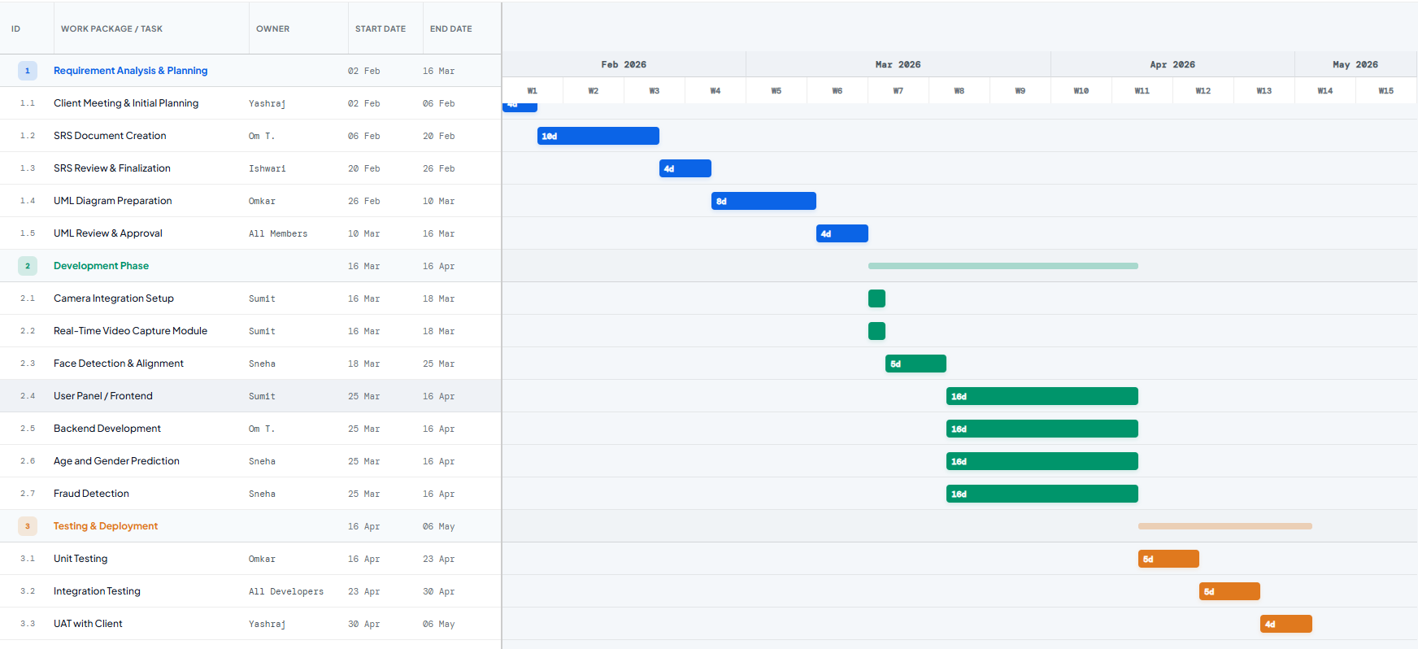

5. Comprehensive Project Estimations

5.1 Risk Register & Mitigation
Risk | Probability | Impact | Mitigation Strategy
Low lighting / Poor camera quality | High | High | Implement front-end checks requesting the user to move to a well-lit area before capturing.
Presentation Attacks (Spoofing) | Medium | High | Integrate liveness detection checks (e.g., blink detection) in the ML pipeline.
High GPU Cloud Costs | Medium | Medium | Optimize the ML model size (e.g., using MobileNet architectures) and terminate idle instances.
Latency in Prediction | Medium | High | Process frames asynchronously; show a loading animation on the frontend so the user doesn't refresh.

5.2 Quality Metrics & Acceptance Criteria
Quality Metric | Target | Measurement Method
Model Accuracy | >90% | Validation against testing datasets for age variance and gender.
Inference Latency | < 500ms | Track the time from frame capture to API response.
System Uptime | 99.9% | Cloud hosting monitoring tools.
False Rejection Rate | < 5% | Monitor failed verifications that require manual override.

5.3 Assumptions & Constraints
- Assumptions: All 6 group members will be available for the entire 12-week timeline. Senim Solutions will provide clear feedback during the UAT phase.
- Constraints: High-accuracy real-time video processing requires adequate hardware, placing a constraint on utilizing strictly free-tier cloud services. The system must operate smoothly across standard web browsers without requiring users to install native applications.

